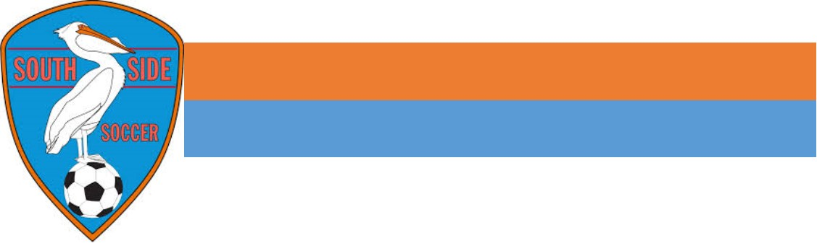
South Side Youth Soccer
Seasonal Team Sponsorship Form
Company:__________________________________________ Contact Person: _________________________
Address:___________________________________ City:__________________ State: ________ Zip: _________
Phone: ____________________________________ E-Mail: __________________________________________
Website: ___________________________________________________________________________________

____ Team Sponsorship - $200 (U7 and Up teams) / $150 (U4-U6 teams)
Sponsorship includes your company name displayed on a team sign at each game your team plays during the season at the Youngsville or Broussard Sports Complex. Attempts will also be made for special recognition through social media as well.

____ Banner Sponsorship – $250/$500 (1/2 Banner / Full Banner)
Sponsorship includes either half or a whole 4X8 banner which includes the sponsors company name, logo (provided by sponsor), phone number, and address. These banners will be displayed along the “sponsor wall” at the Southside Youth Soccer Complex off of Highway 92 in Youngsville.

____ Field Sponsorship - $1,000
Sponsorship includes your company logo prominently displayed on “1” Monsoon Portable Billboard at the Youngsville Sports Complex. Graphic display is 8 feet X 3 feet. This option is a one-year commitment of advertising.

Our program is 100% self-funded by our members and receives no financial support other than the donations and sponsorships we receive. These monies are fully spent on running the organization and maintaining and improving the complex for the safety and enjoyment of our members.

SSYS is a non-profit organization. All sponsorships are tax deductible (LSC Tax# 38-3810503). Your contribution to the Louisiana Soccer Club, Inc., DBA South Side Youth Soccer is greatly appreciated. With your support, we can offer so much more to the children that partake in our programs.

SPONSORSHIP TERMS: Dollar amounts displayed for banner sponsorships and field sponsorships are annual fees. Individual team sponsorships are for the allotted season only. Full payment in U.S. dollars must accompany the signed agreement. All signage will be displayed, as noted in the sponsorship details section for optimized exposure. Renewal notices will be mailed 2 months prior to contract expiration. If request for renewal is not received upon completion of contract terms, all sponsorship benefits will be terminated. Sponsors are responsible for supplying artwork, logos, text, etc. for signage. SSYS will offer minimal graphic design assistance for signage. Signage placement is at the discretion of SSYS, but premium placement will be assigned as sponsorships are secured.

____________________________________________ __________________________________________
Sponsor Authorized Agent SSYS Representative

South Side Youth Soccer, 221 Southpark Road, Suite C2
Lafayette, Louisiana 70503
THANK YOU FOR SUPPORTING ACADIANA’S YOUTH!!!

Age Group: _______ Team Name: ________________________ Coach: _________________________

